Will Mookie Ever Play for the Dodgers?

Austin Kim, 3.26.20

**Shoutout to Ula**

Fellow Dodger fan and Piazza Delivery Boys subscriber, Ula Chun shared the following article from the LA Times with us earlier today:

[https://www.latimes.com/sports/dodgers/story/2020-03-26/mookie-betts-might-never-play-dodgers-because-coronavirus-crisis](https://www.latimes.com/sports/dodgers/story/2020-03-26/mookie-betts-might-never-play-dodgers-because-coronavirus-crisis?fbclid=IwAR3Cj1MRdzb7pXPcoDKRdU3Vf9F9-anQuYOKQLPKNBZoREwnREtyCm1KLsY)

**Who the heck is Bill?!**

In short, the article written by Bill Shaikin provides a hypothetical of what could happen if the MLB season is canceled for 2020 due to the coronavirus. The biggest claim Bill makes is [Mookie Betts](https://www.baseball-reference.com/players/b/bettsmo01.shtml) might never play for the Dodgers if that happens. For those who don’t know, [Mookie Betts was traded to the Dodgers](https://www.piazzaboys.com/articles/mookiewood-has-arrived) from the Red Sox this season and is a top 5 player in all of baseball. He is what many believe is the final piece to a memorable championship run. It says in Bill’s description that he was a CA sportswriter of the year honoree. I don’t understand how that happened given his really bad take of Mookie possibly never playing a game in a Dodger uniform due to the coronavirus.

**Why Bill is completely wrong**

Best case scenario, the coronavirus pandemic slows down allowing for the MLB season to start. MLB commissioner Rob Manfred made a statement saying he expects a shortened MLB season to take place with the assumption enough regular season games will be able to be played. Even with the coronavirus suspending the MLB season, it is clear that one of the commissioner’s top priorities is to make sure the 2020 season takes place. The moment the MLB feels it is safe, the season will commence and Mookie will play.

Worst case scenario, the coronavirus pandemic doesn’t get any better and the whole season must be canceled. It’s true that Mookie only has one year left on his contract and is scheduled to be a free agent in 2021, but if no games are played, barring an amendment of the MLB constitution, this year most likely wouldn’t count towards players’ contracts - at least not in full. Look at the following selection from the constitution:

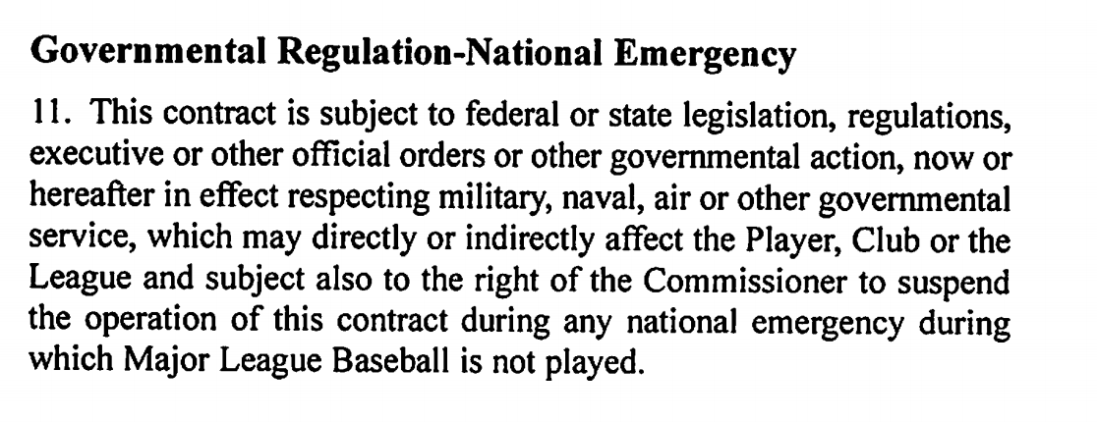

President Trump declared a national emergency on March 13 and Rob Manfred explicitly referenced this when announcing the suspension of the season. Until the national emergency is lifted and/or players play games on the field, according to the MLB constitution, players will not be paid in the meantime. It is hard to imagine a player losing out on the final year of his contract while not being paid for the entirety of it.

In addition to the scenario just mentioned, the MLBPA and MLB have so many other issues to figure out: what to do with upcoming drafts, changes to arbitration qualifications, how service time will be affected, free agency potentially being pushed back, etc. Even though things are not figured out and will take time, I would bet on Mookie playing at least one game for the Dodgers before he puts on another team’s uniform regardless of how 2020 pans out. Don’t forget, the Dodgers also gave up [Alex Verdugo](https://www.baseball-reference.com/players/v/verdual01.shtml) and [Jeter Downs](https://www.baseball-reference.com/register/player.fcgi?id=downs-000jet) to get Mookie. If the MLB allows for Mookie to walk without playing a game for the Dodgers if 2020 is not played out, then Josh and I will stop watching baseball. This would be up there with Manfred giving nothing but a slap on the wrist to the Astros for their sign-stealing scandal. Mookie is only one player on one team. In reality, the coronavirus affects every player (from the minor leaguer to the superstar) and every organization. It’s hard to imagine that contracts would resume as normal during this unprecedented situation.

What Bill says is true... there is a proposition at the negotiation table for players who played a full season in 2019 to be eligible to have played a full season in 2020. However, there is no way that is going to happen for the reasons stated above. I would think it’s common knowledge that the initial propositions at a negotiation table are hardly ever part of the final product as-is.

The LA Times sports department needs to stop writing clickbait articles and stop scaring fans for no reason.

**TLDR**

Bill Shaikin wrote a scrubby article and Mookie will play for the Dodgers when, Lord-willing, this pandemic ends. If he doesn’t, then I will stop watching baseball forever.

*Writer’s Note*:

Dear reader,

Please do your part in helping slow the spread of the COVID-19 pandemic. Wash your hands, stay inside as much as you can, practice social distancing, and care for those around you.

Stay safe.

With love,

Austin